



Minister of Foreign Affairs & International Cooperations

Somalia's Induction into the East African Community

introduction

Somalia is on the verge of becoming a member of the East African Community (EAC), with an official induction date set for November 23, 2023. This follows a comprehensive evaluation process, including a verification mission in Mogadishu from January 25 to February 3, 2023, to assess Somalia's readiness and compliance with the criteria outlined in the “Treaty for the Establishment of the East African Community.”

# Verification Process and Acceptance

The verification mission focused on examining Somalia's institutional and legal frameworks, policies, strategies, and programs, as well as its potential areas of cooperation with existing EAC Partner States.

The findings of this mission contributed to a comprehensive report on Somalia, which was accepted at the EAC Heads of State Summit in Bujumbura, Burundi, on February 4, 2023.

# Negotiation Phase

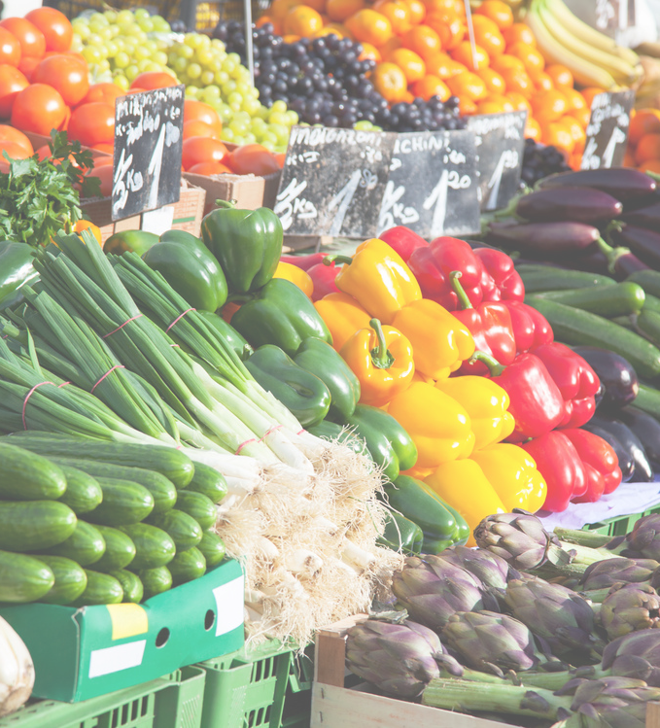Further negotiations took place between Somalia and the EAC Partner States from August 22 to September 30, 2023, in Nairobi, Kenya. These negotiations involved experts from the seven EAC Partner States, the EAC Secretariat, the East African Legislative Assembly, and the East African Court of Justice, along with their Somali counterparts. A roadmap for Somalia's accession was agreed upon during these discussions.

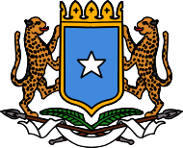Minister of Foreign Affairs & International Cooperations

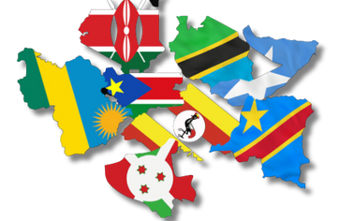***Somalia's Contributions to the EAC Somalia is set to bring significant assets to the EAC, including:***

1. Geographical Advantage: With the longest coastline in Africa, spanning over 3,000 KM along the Gulf of Aden and the Indian Ocean, Somalia offers strategic access to key maritime routes.
2. Economic and Trade Integration: Somalia's position as a bridge between Africa and the Arabian Peninsula is poised to enhance intraregional trade within the EAC and beyond.
3. Historical and Cultural Ties: Somalia shares borders and has strong historical, linguistic, economic, and sociocultural connections with EAC Partner States, particularly Kenya.
4. Entrepreneurial Influence: Somali entrepreneurs have long been active in East Africa, fostering integration with neighboring countries even before formal EAC membership discussions.
5. Livestock Industry: As a leading livestock exporter in the region, Somalia's livestock sector is a major asset. The FAO highlights the sector's significant growth potential, fueled by domestic and export demand.
6. Food Security and Trade: Somalia's contribution in this area is crucial for regional stability and economic growth.
7. Bridge to the Arab and Islamic World: Somalia's unique position enhances the EAC's connection with the Arab and Islamic world, offering economic and cultural benefits.

# Call for Support

As the EAC Partner States' Summit approaches on November 25, 2023, Somalia seeks solidarity and support for its accession as the 8th member of the EAC. Somalia's membership is expected to bolster trade opportunities, regional stability, and economic growth, highlighting its positive contributions to the East African Community.





Minister of Foreign Affairs & International Cooperations

Joining the East African Community: A Strategic Leap Forward

The admission of Somalia into the East

African Community (EAC) is more than just a diplomatic achievement; it's a testament to

Somalia's commitment to regional integration and cooperation. This move, expected to be

formalized at the November summit,

symbolizes a turning point for Somalia, aligning it with regional economies and expanding its market access to over 300 million people.

The admission of Somalia into the East African Community (EAC) represents a

significant milestone not only for Somalia but also for the EAC. As Somalia is expected to be officially integrated into the EAC at the upcoming November summit, it's important to understand the implications of this strategic move.

Joining the EAC is a clear indication of Somalia's commitment to regional

integration, which is crucial for the stability and economic growth of the region. This

integration allows for the expansion of market access, potentially benefiting

Somalia's economy by opening trade routes to a combined market of over 300 million people across the EAC member states.

For Somalia, a country that has faced

numerous challenges over the past decades, including civil war and political instability,

this is a significant leap forward. It not only marks a step towards political stabilization but also economic revival. By aligning with the EAC's frameworks and policies, Somalia is positioning itself to take advantage of shared resources, knowledge, and trade opportunities.

Furthermore, Somalia's admission into the EAC could act as a catalyst for more robust economic policies, attracting foreign

investment, and improving infrastructure. It will also pave the way for the country to play a more prominent role in regional affairs, contributing to peace and security initiatives that are often coordinated by the EAC.

The potential increase in trade and investment opportunities is expected to boost industries such as agriculture,

fisheries, and livestock, which are mainstays of the Somali economy. The integration into the EAC could also lead to improved

standards of living for the Somali people as the economy grows and stabilizes.

However, the integration process is not without its challenges. Somalia will need to align its laws, policies, and regulations with those of the EAC to enable the free movement of goods, labor, and capital.

There will be a need for significant reforms within Somalia to meet the standards set by the EAC, which could require substantial time and effort.

In conclusion, Somalia's anticipated entry into the East African Community is a testament to its resilience and forward- looking stance. While there are hurdles to overcome, the strategic benefits of

increased market access, economic growth, and regional cooperation hold the promise of a brighter future for Somalia and its people. This is a strategic leap forward, not only for Somalia but also for the East African region as it continues to integrate and

strengthen its collective economic and political stature on the global stage

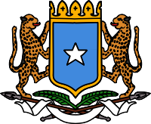Minister of Foreign Affairs & International Cooperations

